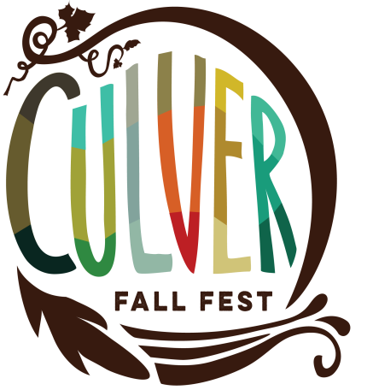

FOOD VENDOR ACCEPTANCE FORM
Oct. 4th 5th & 6th, 2019

CONTACT INFORMATION

Business Name:___________________________________Contact Person______________________

Complete Address:______________________________________________________________________

Business Phone:_____________Cell Phone:___________Email:______________________________

State Tax ID #______________________ Marshall Co. Health Dept. Permit: _________________

Booth Type: __Food Truck __Open Prep Food Booth __ Pre-Packaged Food Booth

COMPLETE MENU DESCRIPTION:_____________________________________________________

________________________________________________________________________________________

Will you be using a generator? ______Yes ______No

FOOD BOOTHS
10X10 Booth Space or
Length of Truck/Trailer Booth Space ___ x $100.00 = $_______ WATER LIMITED provide own hoses ___ X $ 15.00 = $_______
Mandatory Cleaning Deposit: ___ x $50.00 = $_______
(*Refundable on last day of event)

110 Electricity (very limited) ____ x $25.00 = $_______
Must bring extra cords/adapters
Total enclosed and must be received by 09/18/19 $________

Check to: Culver Chamber of Commerce. Address & mail to: Fall Fest Vendor,
103 S. Main St., Culver, IN 46511 or drop off to Amy at Overmyer Water, Culver.

FOOD VENDOR INFORMATION, RULES AND REGULATIONS

Booth Space
Food vendor spaces are 10X10 ft. Food trucks will be assigned based on size and needs.
Only booth space is provided. You must provide your own canopies, tents, tables chairs, trash cans, and extension cords, as needed.

Festival Hours/Set-up/Breakdown
The festival will be open beginning at 5:00 PM - 9:00 PM on Friday, Saturday 9:00 am-10:00 PM and Sunday 10:00 am - 3:00 PM. Vendors MUST remain open throughout the entire festival. There will be live music both Friday and Saturday. You are welcome to remain open past 9:00, if you wish.

Food Vendors will be allowed in the staging area for unloading from 3:00 PM on Friday and from 6:00-9:00 am on Saturday and Sunday. You may not begin assembling your booth until after your vehicle is removed from the staging area. Parking is available along the side streets or at the closed auto store one block south of event space or CVS parking lot.

All vendors must have their space cleared and cleaned no later than 5:00 PM on
Sunday.

Health Permits
Food vendors must provide a list of all foods to be sold, including whether foods are
Prepackaged or prepared on-site.
All food vendors are responsible for the appropriate heath permits and fees with the
Marshall County Health Department.

CLEAN-UP
NO EARLY DEPARTURES. All booths must remain open until the conclusion
of the festival on Sunday, 3:00 PM.
It is the responsibility of the vendor to clean the allotted booth space including
removal of all their own trash. NO GREASE on streets or sidewalks. The mandatory $50.00 cleaning deposit will be re turned upon final inspection prior to leaving on Sunday.

ELECTRICITY
Limited electricity will be available to participants and will be assigned on a first
come, first serve basis. You may NOT request electricity on the day of the event. ALL
cords and hoses MUST be secured to prevent tripping hazards.

Application Information/Booth Assignments
Vendor acceptance and booth assignments are made on a first come, first served
basis, according to when the application AND payment are received.
When mailing your completed and signed application, please include payment by
check or money order ONLY.
Cancellations must be received in written form no later than Sept. 15th. Cancellations received by this date will be granted a refund MINUS a $40.00 process
fee. No refunds will be granted after this date.
Vendor confirmation and booth assignments will be EMAILED out no later than 2
weeks prior to the event date. No paper confirmation will be sent so please make
sure to have a valid email address on file.

Vendor Checklist:

* Include your email address to receive correspondence and information
* Complete, sign, and enclose vendor application WITH payment.
* INCLUDE a $50.00 refundable cleaning deposit.

All vendors must have an approved application on file with Culver Fall Fest to share, sample, or sell products with the public within the event footprint. Culver Chamber of Commerce and the Festival Committee assume no responsibility for any loss, damage, injury, or claim arising out of the participant's acts or omissions in the Culver Fall Fest. Further, the participant shall defend and indemnify Culver Chamber of Commerce and Festival Committee for negligence, fault, misconduct, and liabilities caused by the participant should said negligence, fault, and/or misconduct lead to the filing of a claim or legal action. The participant agrees to abide by the Information, Rules, and Regulations outlined in this document.

Printed Name:____________________________________________________________

Signature: ___________________________________________ Date:______________

Make checks payable to:

Culver Chamber of Commerce
Address & Mail To:
Fall Fest Vendors
103 S. Main St. Culver, IN 46511
OR
Drop off payment to Amy at Overmyer
114 E. Jefferson St., Culver, IN

For any questions feel free to contact:

Angelina Giuliani, Food Vendor Committee Chairman
Phone: 574-276-6500
Email: angelina772@msn.com

